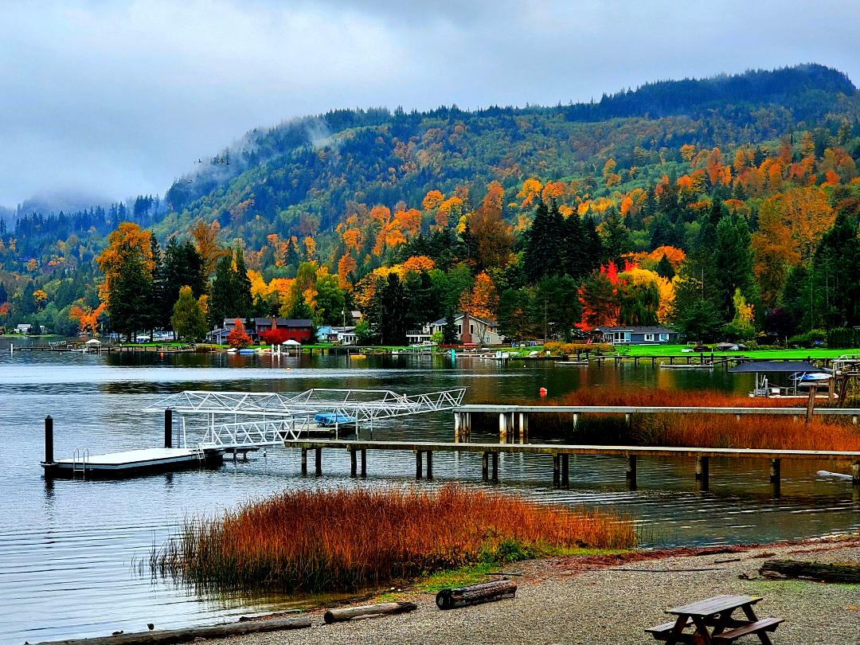

The 2020 Souvenir Calendars are still available at the Big Lake store at $15.00 each.  The photographs in this calendar are an interesting look at the then and now of familiar places in and around the Big Lake communities. Those wishing to get your calendar by mail, may send a check made out to the BLHS in the amount of $16.00 (which includes postage) to:

**BLHS CALENDAR**

**C/O Pattie Hanstad Pleas**

**17550 Dunbar Road**

**Mount Vernon, WA 98273**

*Big Lake Valley,* BLHS’s book of the early history of our local communities is also available at the Big Lake store for $21.99 or may be purchased through the mail by sending a check made out to the BLHS in the amount of $23.00 (includes postage) to Melba Hall, address on the left.

Books & 2020 BLHS Calendars

Are Available for Purchase

CONTACT BLHS:

Melba Hall

Big Lake Historical Society

23694 DaLacy Ln

Mount Vernon, WA 98274

**Trudi Yarcho Davis**

Email: biglakehistoricalsociety@gmail.com

Website: www.biglakehistory.org

**Norma Everett Dyrk Meyers**

**Jim Farmer Pattie Pleas**

**Ginger Govern Lloyd Watkinson**

**Melba Hall James Weppler**

**Kyle Hoffman**

**Newsletter/Website—Trudi Yarcho Davis**

***A people without the knowledge of their past history, origin and culture is like a tree without roots. –Marcus Garvey***

**Calendar Committee Chairperson comments on 2022 Calendar:**

Hello to all BLHS members. With COVID_19 beginning to be seen in our rear-view mirror and with approximately 18 months of restrictions on events, schooling, and social gatherings I was thinking about our 2022 calendar. I felt that it would be nice to see something different and colorful in our 2022 calendar. I came across some photography of a local Big Lake resident by the name of Kym Pickup Larvie and asked her if she would be interested in sharing her photos for our 2022 calendar. She was ever so pleased to share them with us, with the understanding that all rights to the photos would remain hers. I met with the calendar committee to display and explain my idea and the photos were met with appreciation. However, it was brought to my attention that the membership may be concerned that only the photos of one person were being used and that they would not be of historical value. This was something that I had not considered. My enthusiasm was focused on Kym’s photos and offering them as something beautiful in our 2022 calendar. (Something different following COVID_19 restrictions and in some regard, perhaps a bit of history for our future.) I hope you will enjoy the 2022 calendar as much as I have in putting it together. The BLHS Calendar committee would like you to share your thoughts with us either before or after seeing the calendar. Personally, I think it will be a good seller and fund raiser for us and apologize if I have taken steps without more consideration. We hope to have the 2022 calendar available by the first part of September this year. Our 2023 calendar will return to showing historical photos from our community’s past and we would be ever so grateful to see your old photos for consideration. If you have any questions, concerns, or comments you are welcome to email me personally at [blvdbiglakegirl@aol.com](mailto:blvdbiglakegirl@aol.com) or email BLHS at biglakehistoricalsociety@gmail.com.

.

**Pattie Hanstad Pleas—Committee Chairperson**

##### **Introducing the 2022 BLHS Calendar**

# The more things change, the more they stay the same. . . .

#### **BOARD**

**President Jim Farmer**

**Vice President Lloyd Watkinson**

**Secretary Pattie Pleas**

**Treasurer/Historian Melba Hall**

### HISTORICAL SOCIETY OFFICERS

**BLHS NEWSLETTER**



**My Blissful Big Lake Childhood**

**As Told by Carol (Roundal) Rondell**

***OUR STORIES***

Mom and Dad, Robert and Helen Roundal bought one of the original worker’s cottages (Big Lake Day Lumber Co.) on Lakeview Boulevard in the early 1940’s. Our family didn’t have much money, but as children we were very rich with our Big Lake lifestyle. We had the lake to fish and swim in, as well as horses, dogs, cats, and fields to roam and run in whenever we felt like it.

It was the early 50’s. My sister, Connie and I were always trying to earn money for our horses’ upkeep such as pasture rent, feed, and horseshoes. I can remember peeling cascara bark, picking ferns for a funeral home, collecting beer and pop bottles via gunny sack, babysitting, and in summer picking strawberries or working in the bulb fields.

My sis and I rented the pasture where the Big Lake Park is now. Just have to mention, I am thrilled it’s a park now, the view of Mount Baker is spectacular on a clear day. Anyway, I acquired my horse, Elizabeth Lightfoot (Lizzie for short) from the McClintock Ranch (Valley View Dairy Farm). She was running loose on 80 acres. They said if I could catch her, I could buy her for $35. My dad got all our neighbors and friends to help me retrieve her. That was what was so wonderful about living in Big Lake, it was the sense of community. We had the most caring, loving friends and neighbors. John and Bessie Wilson, Rod and Effie Calkins, Ted Souers, John Vogel, my Uncle Carl, and Aunt Silvia Roundal and so many friends. As kids we were wild and free spirits but always felt safe and secure because we knew we could count on them for any of our needs.

Looking back as a child growing up in Big Lake, I have so many lasting lessons and memories. I will always cherish those years.

**Welcome Back!**

**And**

**It is About Time--**

For our first post-pandemic quarterly meeting of the BLHS. Please plan to attend as we get down to business, share and get re-acquainted.

Where: The Big Lake Community Church

When: Thursday, October 28, 2021

Time: 7:00 PM

Agenda:

1. Welcome back… getting reacquainted.
2. Review the minutes of the last meeting
3. 2022 Calendar Committee report
4. Report from editor—online inquiries and activity.
5. 2022 BLHS Biennial Exhibit—discussion and organization.

**Comments from the editor:**

* ***You are invited to share your history!*** Please do—a special thank you to Carol Rondell and Pattie Pleas (2021 Spring Newsletter) for sharing their stories. Send your stories to:

***BLHS***

***23694 Da Lacy Lane***

***Mount Vernon, WA 98274***

***OR***

***Email: biglakehistoricalsociety@gmail.com***

* ***Concerning the 2022 Calendars***—the more things change, the more they remain the same. As a member of the Big Lake Neighbors Facebook group, I notice the same concerns for community, neighbors looking out for neighbors, and absolute appreciation for the beauty that surrounds us “lakers” as was known in the good “ole days”. I look forward to the new calendar and the wonderful photographs of Kym Pickup Larvie, after all it is our contemporary history, the roots of the coming generations and a bridge between what was and what is and what will always be.
* ***What’s Ahead—***Coming in the Fall Newsletter, “*If The Land Could Talk”*, the biography and autobiography of piece of property through a century, five generations, and two families that lived, worked and loved the land. Stay tuned!

–Trudi Yarcho Davis